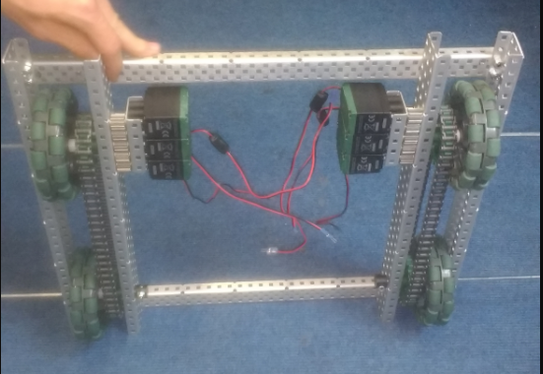

**What needs to be changed:**

* Axels need to be cut and secured
* Need to add a plate for mounting

**WHAT HAS BEEN CHANGED:**

* Motors been moved from the primary frame to a secondary mounting
* 2 of the wheels have been removed

By Robbie Buxton

20/6/2017 – 16:14

**Overview:**

This is our second version of our robot. With the first prototype, we found that too much space was being wasted by the system allowing all the motors being blocked together reducing the space in the centre of the robot we needed for our intake device. We decided to make the motor block a modular attachment. We will most likely keep this basic design for the next versions of the robot however it need some additions and changes such as securing axels and the addition of a mounting plate for our lifting device.

SPECIFICATIONS:

* 6 Motor HS drive
* Two drive chains
* 4 wheels
* Aluminium structure

DIMENTIONS:

17.5” * 15”

Robot V 1.10